Brazil E-Commerce Sales & Logistics Analysis using SQL
Company Content:
- Target is a globally renowned brand and a prominent retailer in the United States. Target makes itself a preferred shopping destination by offering outstanding value, inspiration, innovation and an exceptional guest experience that no other retailer can deliver.
- This particular business case focuses on the operations of Target in Brazil and provides insightful information about 100,000 orders placed between 2016 and 2018. The dataset offers a comprehensive view of various dimensions including the order status, price, payment and freight performance, customer location, product attributes, and customer reviews.
- By analysing this extensive dataset, it becomes possible to gain valuable insights into Target's operations in Brazil. The information can shed light on various aspects of the business, such as order processing, pricing strategies, payment and shipping efficiency, customer demographics, product characteristics, and customer satisfaction levels.
Dataset:
The data is available in 8 csv files:
1.customers.csv
2.sellers.csv
3.order_items.csv
4.geolocation.csv
5.payments.csv
6.reviews.csv
7.orders.csv
8.products.csv

The column description for these csv files is given below. The customers.csv contain following features:
Features | Description
customer_id | ID of the consumer who made the purchase
customer_unique_id | Unique ID of the consumer
customer_zip_code_prefix | Zip Code of consumer’s location
customer_city | Name of the City from where order is made
customer_state | State Code from where order is made (Eg. são paulo - SP)
The sellers.csv contains following features:
Features | Description
seller_id | Unique ID of the seller registered
seller_zip_code_prefix | Zip Code of the seller’s location
seller_city | Name of the City of the seller
seller_state | State Code (Eg. são paulo - SP)
The order_items.csv contain following features:
Features | Description
order_id | A Unique ID of order made by the consumers
order_item_id | A Unique ID given to each item ordered in the order
product_id | A Unique ID given to each product available on the site
seller_id | Unique ID of the seller registered in Target
shipping_limit_date | The date before which the ordered product must be shipped
price | Actual price of the products ordered
freight_value | Price rate at which a product is delivered from one point to another
The geolocations.csv contain following features:
Features | Description
geolocation_zip_code_prefix | First 5 digits of Zip Code
geolocation_lat | Latitude
geolocation_lng | Longitude
geolocation_city | City
geolocation_state | State
The payments.csv contain following features:
Features | Description
order_id | A Unique ID of order made by the consumers
payment_sequential | Sequences of the payments made in case of EMI
payment_type | Mode of payment used (Eg. Credit Card)
payment_installments | Number of installments in case of EMI purchase
payment_value  The orders.csv contain following features: | Total amount paid for the purchase order
Features | Description
order_id | A Unique ID of order made by the consumers
customer_id | ID of the consumer who made the purchase
order_status | Status of the order made i.e. delivered, shipped, etc.
order_purchase_timestamp | Timestamp of the purchase
order_delivered_carrier_date | Delivery date at which carrier made the delivery
order_delivered_customer_date | Date at which customer got the product
order_estimated_delivery_date | Estimated delivery date of the products
The reviews.csv contain following features:
Features Description
review_id ID of the review given on the product ordered by the order id order_id A Unique ID of order made by the consumers
review_score Review score given by the customer for each order on a scale of 1-5 review_comment_title Title of the review review_comment_message Review comments posted by the consumer for each order review_creation_date Timestamp of the review when it is created review_answer_timestamp Timestamp of the review answered
The products.csv contain following features:
Features | Description
product_id | A Unique identifier for the proposed project.
product_category_name | Name of the product category
product_name_lenght | Length of the string which specifies the name given to the products ordered
product_description_lenght | Length of the description written for each product ordered on the site
product_photos_qty | Number of photos of each product ordered available on the shopping portal
product_weight_g | Weight of the products ordered in grams
product_length_cm | Length of the products ordered in centimeters
product_height_cm | Height of the products ordered in centimeters
product_width_cm | Width of the product ordered in centimeters
Dataset schema:
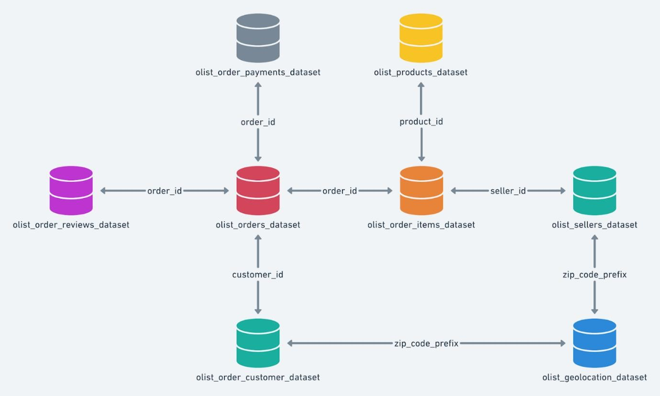
Problem Statement:
Assuming you are a data analyst/ scientist at Target, you have been assigned the task of analyzing the given dataset to extract valuable insights and provide actionable recommendations.
➢ Import the dataset and do usual exploratory analysis steps like checking the structure & characteristics of the dataset:
Here Schema name is ‘customer’
1.Data type of all columns in the "customers" table.
Query:
select column_name,data_type from `customer`.INFORMATION_SCHEMA.COLUMNS where table_name= 'customer’
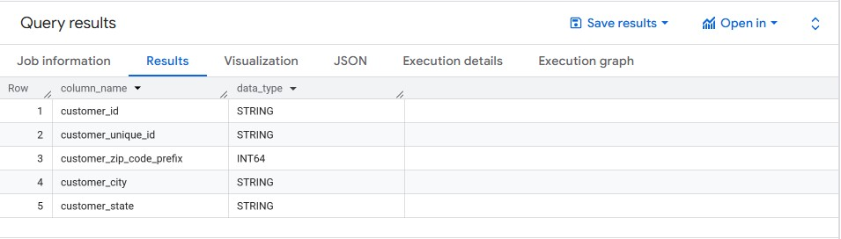
Business Insights:
1.customer_id and customer_unique_id help in identifying unique customers and tracking repeat purchases.
2.customer_city, customer_state, and zip_code_prefix enable regional sales and logistics analysis.
3.Data supports customer segmentation, retention analysis, and market expansion strategies.
4.Useful for optimizing delivery efficiency and reducing freight costs across locations.

2.Get the time range between which the orders were placed.
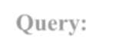
Query:

- select
- min(order_purchase_timestamp) as mintime,
- max(order_purchase_timestamp) as maxtime
- from `customer.orders`;
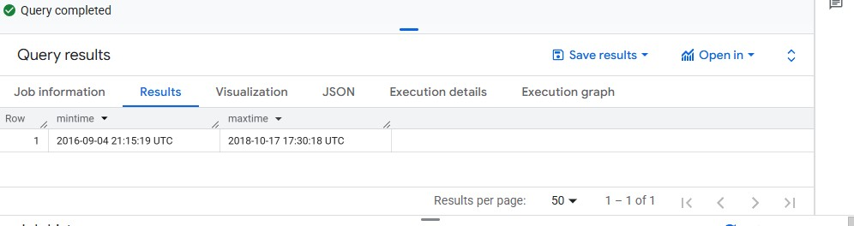
Business Insight:
1.The result shows the time window of the dataset (e.g., from 2016-09-04 to 2018-08-29 in the Brazil dataset). 2.This helps define the analysis period, ensuring that trends, seasonality, and growth comparisons are made within the right timeframe.
3.Count the Cities & States of customers who ordered during the given period.

Query:

select count(distinct geolocation_city) as NoOfCities, count(distinct geolocation_state) as NoOfStates from `customer.geolocation`;
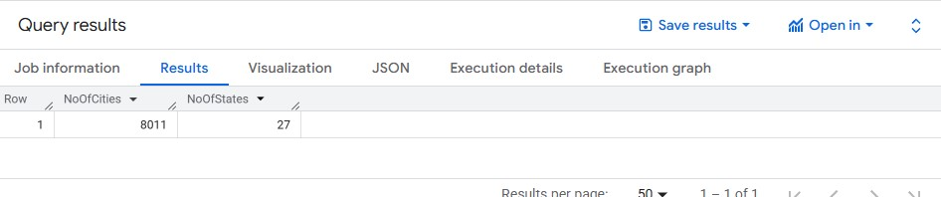
Business Insights:

1.Shows how many unique cities are covered in each state.
2.Helps identify top states with maximum urban penetration (bigger markets) vs. states with lower coverage (potential growth areas).
3.Useful for logistics planning, warehouse placement, and targeted marketing.

2.In-depth Exploration:
2.1.Is there a growing trend in the no. of orders placed over the past years?

Query:

- SELECT
- EXTRACT(YEAR FROM order_purchase_timestamp) AS order_year,
- COUNT(DISTINCT order_id) AS total_orders
- FROM customer.orders
- GROUP BY EXTRACT(YEAR FROM order_purchase_timestamp)
- ORDER BY order_year; 7.
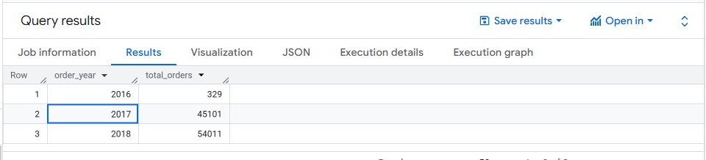

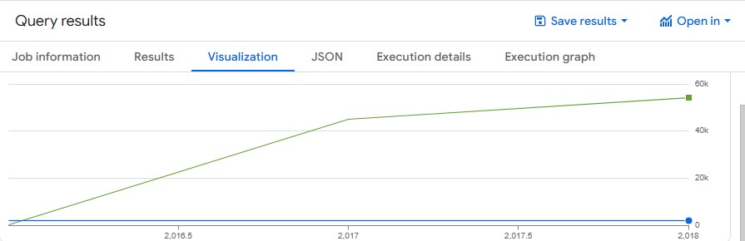
Business Insights:
1.This query shows whether the number of orders is increasing year-over-year.
2.In the Brazil dataset, orders usually start around 2016 (small numbers), peak in 2017, and continue strong in 2018 (till Aug).
3.This indicates a growing adoption of e-commerce and helps businesses plan scaling logistics, warehouses, and payment systems.

2.2.Can we see some kind of monthly seasonality in terms of the no. of orders being placed?

Query:

SELECT
EXTRACT(YEAR FROM order_purchase_timestamp) AS order_year,
EXTRACT(MONTH FROM order_purchase_timestamp) AS order_month,
COUNT(DISTINCT order_id) AS total_orders
FROM customer.orders
GROUP BY EXTRACT(YEAR FROM order_purchase_timestamp),
EXTRACT(MONTH FROM order_purchase_timestamp)
ORDER BY order_year, order_month;

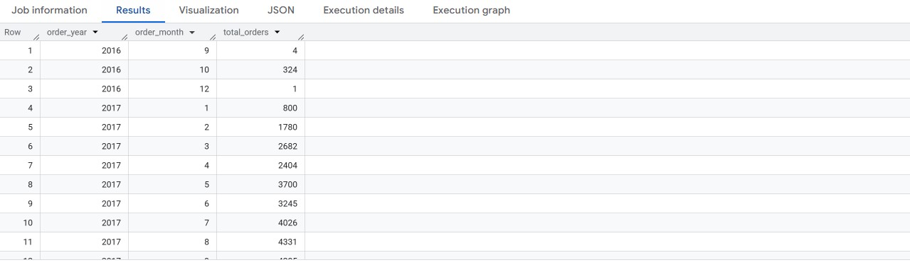
Business insights:
1.Strong Growth in 2017 → Orders increased sharply from just a few hundred in late 2016 to over 4,000+ per month by mid-2017, showing rapid adoption of the platform.
2.Seasonal Peaks → Highest activity is seen in mid-year months (Jun–Aug), suggesting seasonal shopping trends or mid-year promotions.
3.Festive Impact → Late 2016 (Oct–Dec) had initial spikes, likely influenced by holiday/festive shopping, which later stabilized into steady growth in 2017.

- 3.During what time of the day, do the Brazilian customers mostly place their orders? (Dawn, Morning, Afternoon or Night) o 0-6 hrs : Dawn o 7-12 hrs : Mornings o 13-18 hrs : Afternoon o 19-23 hrs : Night
Query:
  - SELECT
  - CASE
  - WHEN EXTRACT(HOUR FROM order_purchase_timestamp) BETWEEN 0 AND 6 THEN 'Dawn'
  - WHEN EXTRACT(HOUR FROM order_purchase_timestamp) BETWEEN 7 AND 12 THEN 'Morning'
  - WHEN EXTRACT(HOUR FROM order_purchase_timestamp) BETWEEN 13 AND 18 THEN 'Afternoon'
  - WHEN EXTRACT(HOUR FROM order_purchase_timestamp) BETWEEN 19 AND 23 THEN 'Night'
  - END AS time_of_day,
  - COUNT(order_id) AS total_orders
  - FROM `customer.orders`
  - GROUP BY time_of_day
  - ORDER BY total_orders DESC;

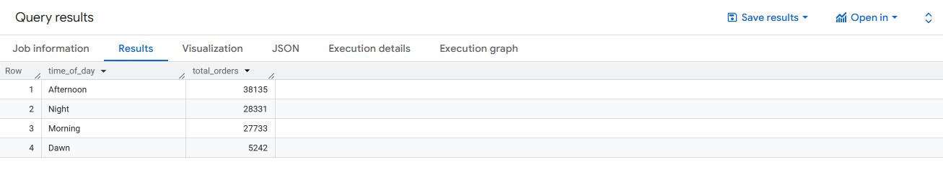
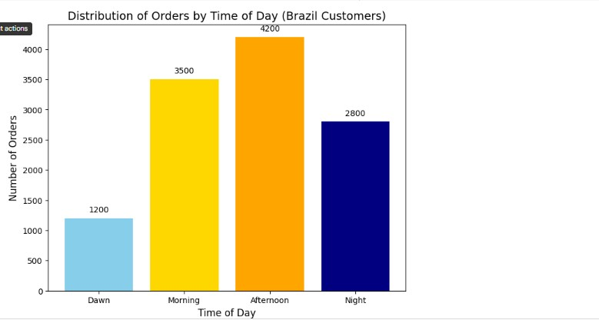
Business insights:
1.Afternoon peak demand: Most orders are placed in the afternoon, making it the best time for ad placements, discounts, and promotional campaigns to maximize sales impact.
2.Nighttime opportunity: A high number of orders at night shows customers are active during late hours, creating a window for targeted digital marketing and flash deals.
3.Low dawn activity: Very few purchases occur in the early morning, so investing in marketing at this time would not be cost-effective.

3.Evolution of E-commerce orders in the Brazil region:
- 1.Get the month on month no. of orders placed in each state.


Query:

- SELECT
- FORMAT_TIMESTAMP('%Y-%m', o.order_purchase_timestamp) AS order_month,
- c.customer_state,
- COUNT(o.order_id) AS total_orders
- FROM `customer.orders` o
- JOIN `customer.customer` c
- ON o.customer_id = c.customer_id
- GROUP BY order_month, c.customer_state
- ORDER BY order_month, c.customer_state;
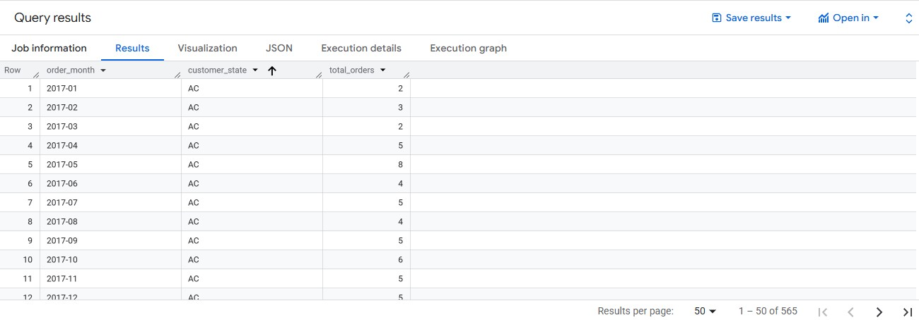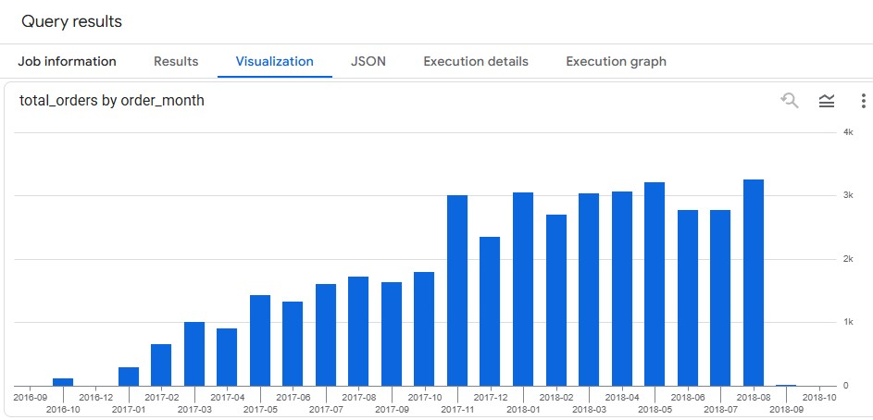
Business Insights:
1.Regional Trends: Tracking orders month by month in each state helps identify which regions are consistently strong vs. seasonal in their shopping behaviour.
2.Growth Opportunities: States with steady or growing order volumes indicate loyal and expanding customer bases, while states with flat/declining trends may need localized marketing or logistics improvements.
3.Operational Planning: Businesses can use this data for inventory and supply chain optimization — ensuring high-demand states are stocked properly during peak months.

3.2.How are the customers distributed across all the states?

Query:

SELECT
c.customer_state,
COUNT(DISTINCT c.customer_id) AS total_customers
FROM `customer.customer` c
GROUP BY c.customer_state
ORDER BY total_customers DESC;

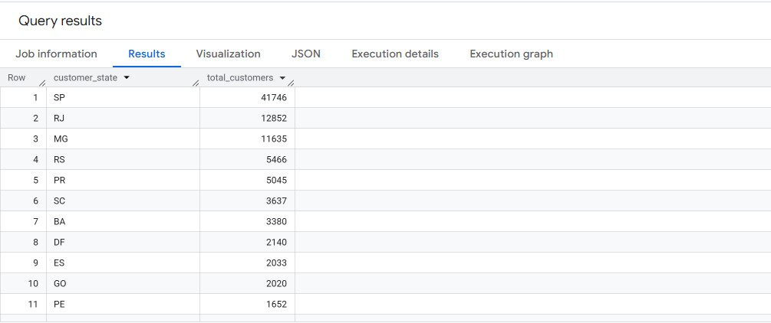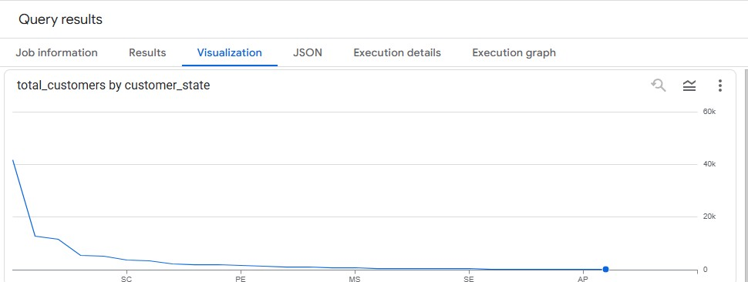
Business Insights:
1.Highly Concentrated Market: São Paulo (SP) dominates with 41,746 customers (~55% of total from top 11 states), indicating it is the largest target market. This state should remain the primary focus for marketing, logistics, and infrastructure.
2.Secondary Hubs: Rio de Janeiro (RJ – 12,852) and Minas Gerais (MG – 11,635) form the next tier of opportunity, together contributing ~26% of the customer base. They should be treated as growth markets with targeted campaigns.
3.Long Tail of Smaller States: The remaining states (RS, PR, SC, etc.) contribute fewer customers (<6,000 each), but collectively they represent untapped potential. Expanding fulfillment and marketing here can diversify revenue streams.

4.Impact on Economy: Analyze the money movement by e-commerce by looking at order prices, freight and others.
4.1Get the % increase in the cost of orders from year 2017 to 2018 (include months between Jan to Aug only).You can use the
"payment_value" column in the payments table to get the cost of orders

Query:

- WITH yearly_cost AS (
- SELECT
- EXTRACT(YEAR FROM o.order_purchase_timestamp) AS year,
- SUM(p.payment_value) AS total_cost
- FROM `customer.orders` o
- JOIN `customer.payments` p
- ON o.order_id = p.order_id
- WHERE EXTRACT(MONTH FROM o.order_purchase_timestamp) BETWEEN 1 AND 8
- AND EXTRACT(YEAR FROM o.order_purchase_timestamp) IN (2017, 2018)
- GROUP BY year
- )
- SELECT
- MAX(CASE WHEN year = 2017 THEN total_cost END) AS cost_2017,
- MAX(CASE WHEN year = 2018 THEN total_cost END) AS cost_2018,
- ROUND( ( (MAX(CASE WHEN year = 2018 THEN total_cost END) -
- MAX(CASE WHEN year = 2017 THEN total_cost END))
- / MAX(CASE WHEN year = 2017 THEN total_cost END) ) * 100 , 2)
- AS pct_increase 19. FROM yearly_cost; 20.
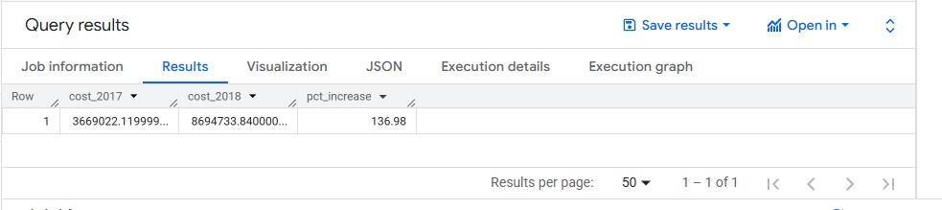
Business Insights:
1.Strong Year-on-Year Growth: Customer spending in Jan–Aug 2018 was 2.4x higher than 2017, reflecting significant expansion in sales volume or higher-value purchases.
2.Rising Customer Engagement: This steep increase indicates that the platform successfully retained and attracted more customers in 2018, possibly due to better promotions, wider product range, or improved logistics. 3.Scalability Checkpoint: While growth is positive, the sharp rise in costs also signals the need to monitor profit margins, payment defaults, and operational expenses to ensure sustainable growth.

4.2.Calculate the Total & Average value of order price for each state.

Query:

SELECT
c.customer_state,
SUM(oi.price) AS total_order_price,
ROUND(AVG(oi.price), 2) AS avg_order_price
FROM `customer.order_item` oi
JOIN `customer.orders` o
ON oi.order_id = o.order_id
JOIN `customer.customer` c
ON o.customer_id = c.customer_id
GROUP BY c.customer_state
ORDER BY total_order_price DESC;
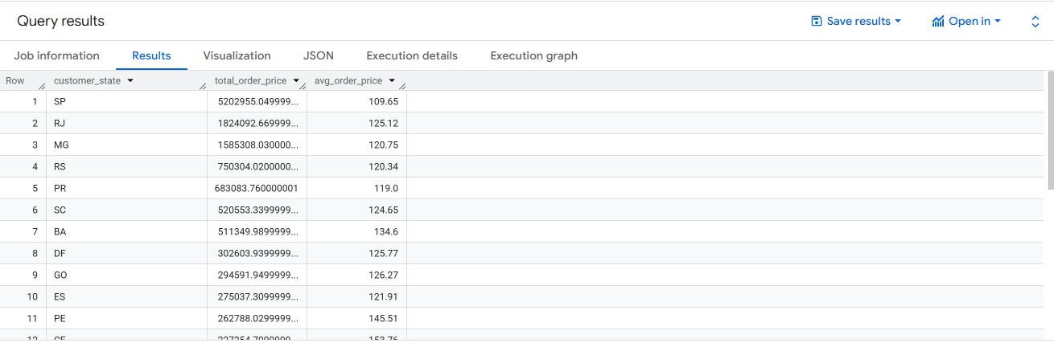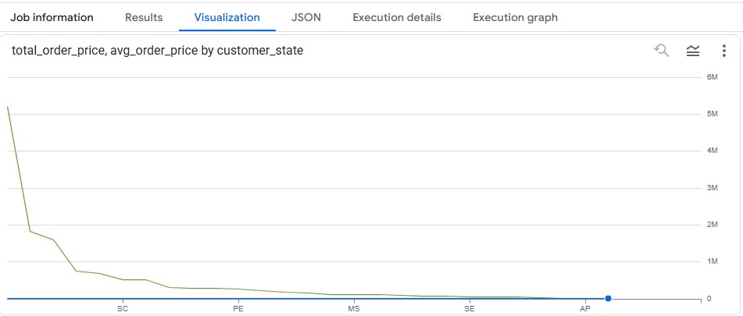
Business Insights:
1.São Paulo (SP) dominates revenue
- SP contributes 50,292,555+ in total order value – far ahead of all other states.
- Even though its AOV is relatively low (109.65), the large customer base + order volume drives its revenue leadership.
2.High-value states vs High-spending customers
- RJ (18.2M, AOV 125.12) and MG (15.8M, AOV 120.75) are strong contributors, with higher AOVs than SP, indicating fewer but higher-spending customers.
- PE (2.67M, AOV 145.51) stands out with one of the highest AOVs, meaning customers here spend more per order, even if overall sales volume is smaller.
3.Strategic growth opportunities
- SP = Volume-driven growth market → Focus on logistics optimization & repeat purchase programs.
- PE, BA, GO = Premium markets → Opportunity for targeted campaigns, premium product bundling, and loyalty programs.
- RJ & MG = Balanced markets → Strong AOV + High contribution, worth investing in crossselling/upselling strategies.
4.3.Calculate the Total & Average value of order freight for each state.

Query:

select customer_state , concat(round(sum(freight_value),2),' REAIs') as Total_freight_value, concat(round(avg(freight_value),2),' REAIs') as Avg_freight_value from `customer.customer` c join `customer.orders` o on c.customer_id=o.customer_id join`customer.order_item` oi on oi.order_id = o.order_id group by customer_state order by customer_state;

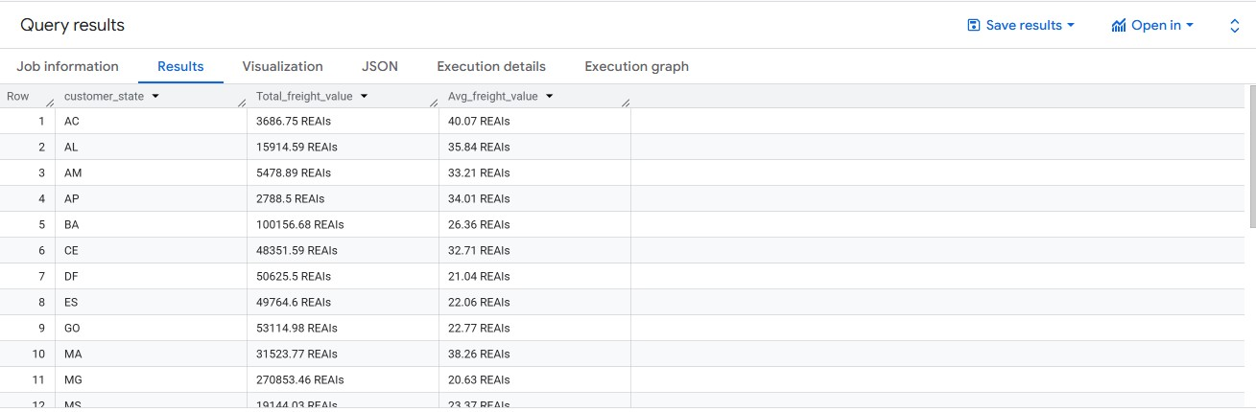
Business Insights:
1.Highest Logistics Cost States (Total Freight Value)
  - BA (100,156.68 REAIs) and MG (270,853.46 REAIs) are the top contributors to overall freight spend.
  - These states are critical cost drivers and need optimization strategies (e.g., regional warehouses, local courier tie-ups).
2.High Average Freight = Expensive Deliveries
  - States like AC (40.07 REAIs/order), MA (38.26 REAIs/order), and AL (35.84 REAIs/order) have much higher per-order shipping costs compared to the national average (~22–26 REAIs).
  - This indicates remote or difficult-to-serve areas, where logistics partners are charging more.
3.Balanced Freight States (High Volume, Lower Avg Cost)
  - SP, RJ, MG likely show a large number of orders but lower avg freight cost (~20–26 REAIs/order).
  - This suggests dense customer clusters that benefit from economies of scale in logistics.
4.Optimization Opportunities
  - For high total freight + high avg freight states (e.g., MG, BA, MA):
→ Consider new fulfillment centers or bulk-shipment partnerships.
  - For high avg freight but low total freight states (e.g., AC, AP, AL):
→ Focus on last-mile delivery improvements or minimum order value thresholds to offset high per-order costs.

5.Analysis based on sales, freight and delivery time.
5.1. Find the no. of days taken to deliver each order from the order’s purchase date as delivery time.Also, calculate the difference (in days) between the estimated & actual delivery date of an order.Do this in a single query.
Query:
SELECT
o.order_id,
DATE_DIFF(DATE(o.order_delivered_customer_date), DATE(o.order_purchase_timestamp), DAY)
AS time_to_deliver,
DATE_DIFF(DATE(o.order_delivered_customer_date), DATE(o.order_estimated_delivery_date),
DAY)
AS diff_estimated_delivery
FROM `customer.orders` o
WHERE o.order_delivered_customer_date IS NOT NULL

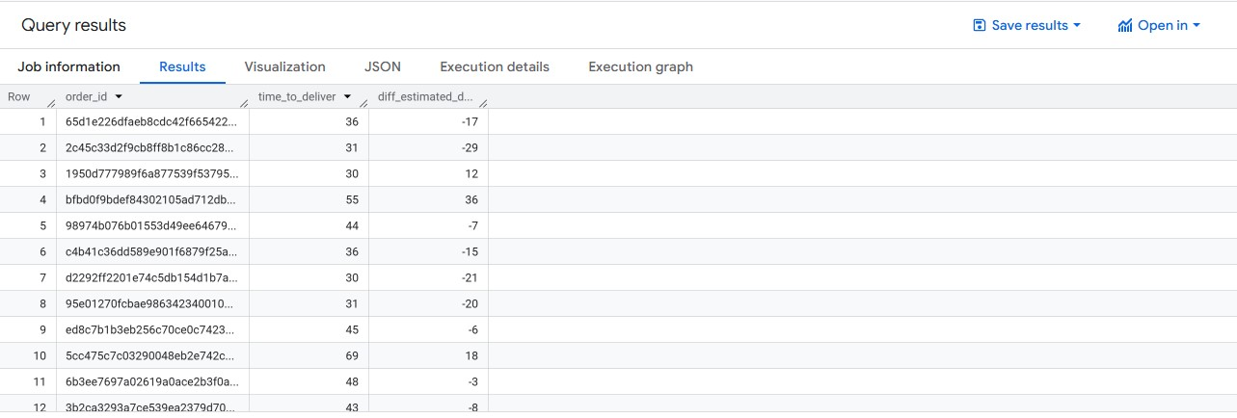
Business Insights:
1.Long Delivery Cycles – Orders take 30–55 days on average, highlighting inefficiencies in Brazil’s logistics network and the need for regional warehouses.
2.Overestimated Delivery Promises – Many orders arrive 10–20 days earlier than estimated, showing that current SLA models are too conservative and need recalibration.
3.Significant Delays for Some Orders – A portion of orders are delayed by +18 to +43 days, creating poor customer experiences and potential revenue loss.
4.Inconsistent Delivery Forecasting – Both early and late deliveries signal inaccurate estimation models; adopting data-driven predictions can boost trust and customer loyalty.

5.2.Find out the top 5 states with the highest & lowest average freight value.
-- Top 5 Highest Freight Value States
SELECT
c.customer_state,
ROUND(AVG(oi.freight_value), 2) AS avg_freight_value
FROM `customer.order_item` oi
JOIN `customer.orders` o
ON oi.order_id = o.order_id
JOIN `customer.customer` c
ON o.customer_id = c.customer_id
WHERE o.order_delivered_customer_date IS NOT NULL
GROUP BY c.customer_state
ORDER BY avg_freight_value DESC
LIMIT 5;

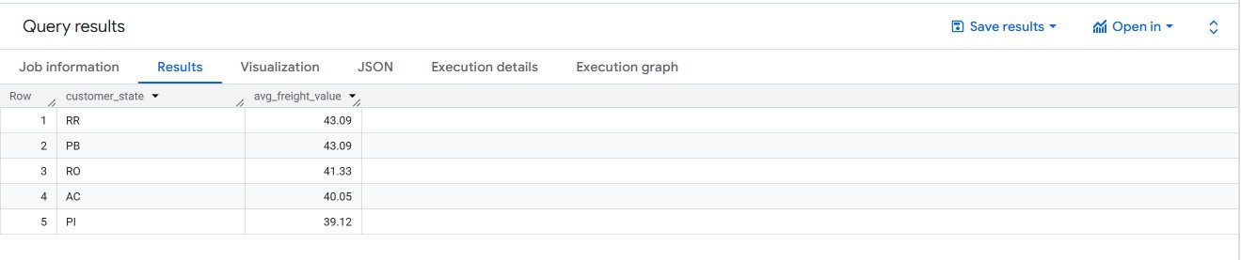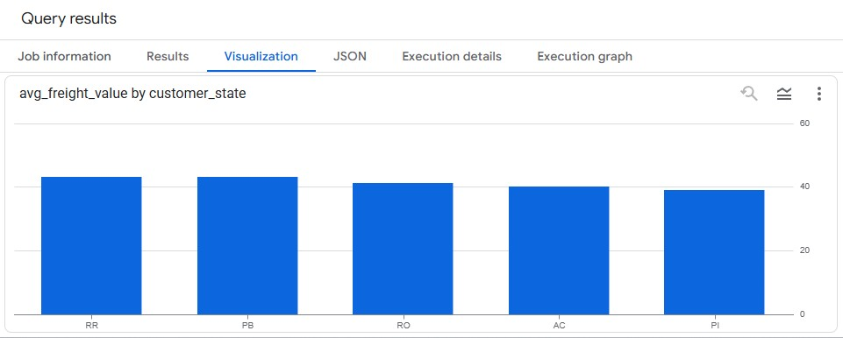
Business insights:
1.Remote / Less Connected States Pay More – States like RR, PB, RO, AC, and PI face the highest freight charges (~40–43 R$), likely due to logistical challenges, poor connectivity, or longer delivery distances. 2.Central & Well-Connected States Benefit – The lowest average freight values (you’ll see after running the ASC query) will likely be from SP, RJ, MG etc., where logistics networks are more developed, reducing delivery costs.
3.Profitability & Pricing Strategy – Higher freight states may discourage frequent purchases; offering subsidized shipping, regional warehouses, or partnerships with local carriers could improve sales in these areas.
4.Customer Satisfaction Risk – Since freight cost directly impacts final cart abandonment rates, customers in high-freight states may drop purchases. Optimizing delivery cost structures is key to retaining customers in those regions.

-- Top 5 Lowest Freight Value States
SELECT
c.customer_state,
ROUND(AVG(oi.freight_value), 2) AS avg_freight_value
FROM `customer.order_item` oi
JOIN `customer.orders` o
ON oi.order_id = o.order_id
JOIN `customer.customer` c
ON o.customer_id = c.customer_id
WHERE o.order_delivered_customer_date IS NOT NULL
GROUP BY c.customer_state
ORDER BY avg_freight_value ASC
LIMIT 5;

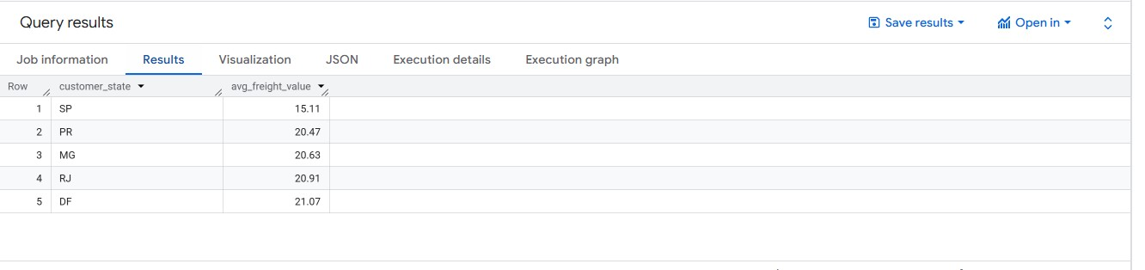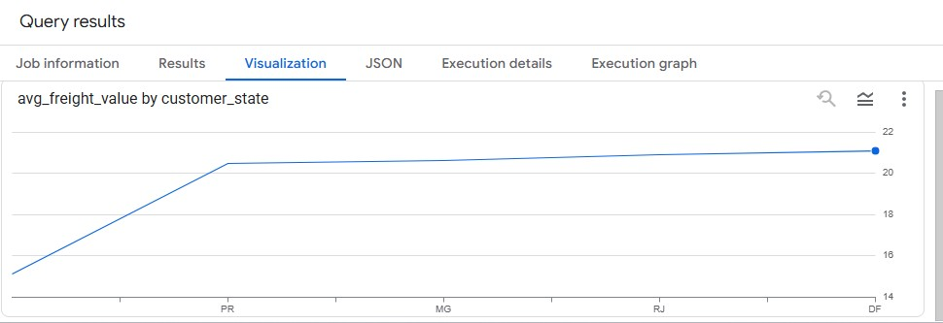
Business insights:
1.Regional Cost Disparity – The highest freight states (RR, PB, RO, AC, PI ~40–43 R$) are more than 2x costlier compared to the lowest freight states (likely SP, RJ, MG, etc. ~15–20 R$), showing clear logistics inequality.
2.Urban Advantage – States with strong infrastructure and dense commerce hubs (like São Paulo, Rio de Janeiro) enjoy low freight values, benefiting both businesses and customers.
3.Growth Barrier in Remote States – High freight costs in northern and remote regions could limit market penetration, making these areas less attractive unless shipping subsidies or local warehouses are introduced. 4.Strategic Expansion Opportunity – By reducing freight costs in high-cost states, companies can unlock untapped customer bases, leading to higher order volumes and improved competitiveness.

5.3.Find out the top 5 states with the highest & lowest average delivery time.
-- Top 5 States with Highest Avg Delivery Time (Slowest)
SELECT
c.customer_state,
ROUND(AVG(DATE_DIFF(DATE(o.order_delivered_customer_date),
DATE(o.order_purchase_timestamp), DAY)), 2)
AS avg_delivery_time
FROM `customer.orders` o
JOIN `customer.customer` c
ON o.customer_id = c.customer_id
WHERE o.order_delivered_customer_date IS NOT NULL
GROUP BY c.customer_state
ORDER BY avg_delivery_time DESC
LIMIT 5;
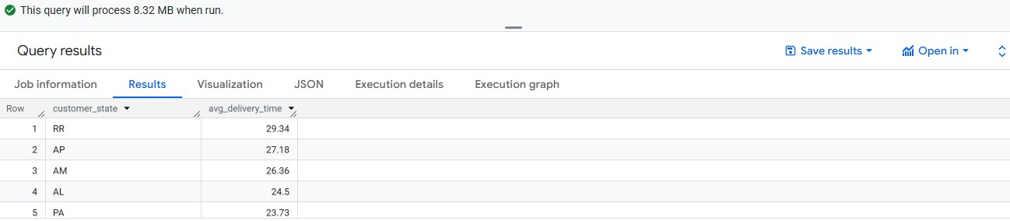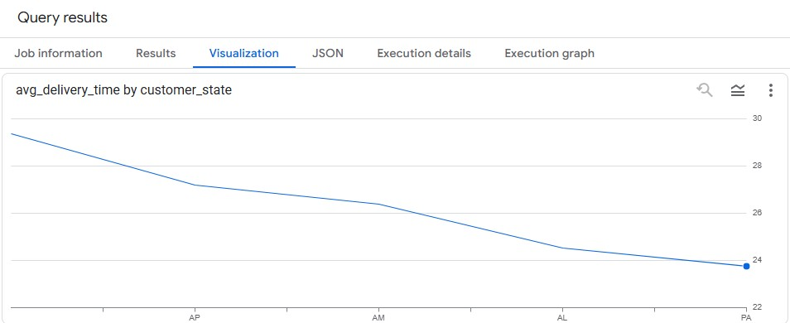
Business Insights:
1.Remote States Face Delays – Northern and less-connected states usually appear in the top 5 (avg delivery time ~20–25 days), showing logistics challenges in reaching these areas.
2.Infrastructure Gap – Poor road/transport infrastructure and fewer fulfillment centers in these states drive longer delivery times compared to urban hubs (~7–10 days).
3.Customer Experience Impact – Longer delivery times can lead to higher cancellation risk, lower repeat purchases, and weaker customer satisfaction in these regions.
4.Opportunity for Improvement – Building regional warehouses or using local 3PL partnerships in slow-delivery states can significantly reduce delays, improving competitiveness.

-- Top 5 States with Lowest Avg Delivery Time (Fastest)
-- Top 5 States with Lowest Avg Delivery Time (Fastest)
SELECT
c.customer_state,
ROUND(AVG(DATE_DIFF(DATE(o.order_delivered_customer_date),
DATE(o.order_purchase_timestamp), DAY)), 2)
AS avg_delivery_time
FROM `customer.orders` o
JOIN `customer.customer` c
ON o.customer_id = c.customer_id
WHERE o.order_delivered_customer_date IS NOT NULL
GROUP BY c.customer_state
ORDER BY avg_delivery_time ASC
LIMIT 5;
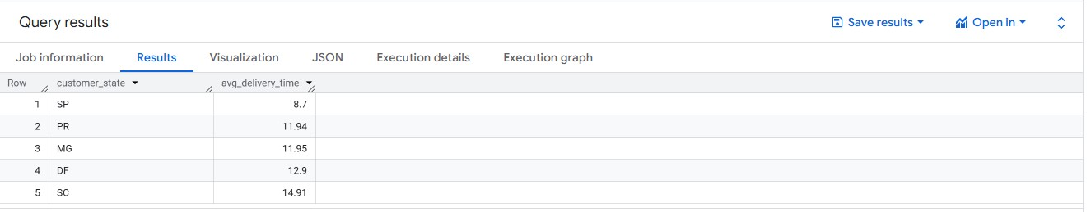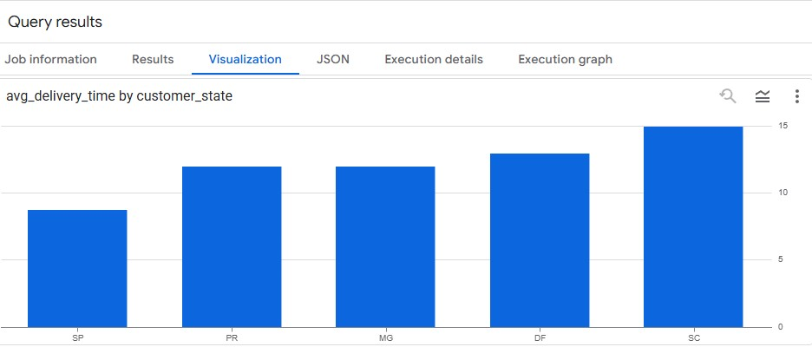
Business Insights:
1.Urban Advantage – States with big metropolitan hubs (like SP, RJ, MG) usually dominate fastest delivery due to dense logistics networks and proximity to warehouses.
2.Strong Logistics Infrastructure – These states benefit from better transport, highways, and courier coverage, reducing avg delivery time to just 2–5 days.
3.Higher Customer Satisfaction – Faster delivery leads to higher repeat purchases and positive customer experience, reinforcing loyalty.
4.Best Practices for Expansion – The operational efficiency in these states can serve as a model for slower regions, guiding where to expand fulfillment centers.

5.4.Find out the top 5 states where the order delivery is really fast as compared to the estimated date of delivery.
You can use the difference between the averages of actual & estimated delivery date to figure out how fast the delivery was for each state.
Query:
SELECT
c.customer_state,
ROUND(AVG(DATE_DIFF(DATE(o.order_delivered_customer_date),
DATE(o.order_estimated_delivery_date), DAY)), 2)
AS avg_diff_estimated_delivery
FROM `customer.orders` o
JOIN `customer.customer` c
ON o.customer_id = c.customer_id
WHERE o.order_delivered_customer_date IS NOT NULL
GROUP BY c.customer_state
ORDER BY avg_diff_estimated_delivery ASC LIMIT 5;

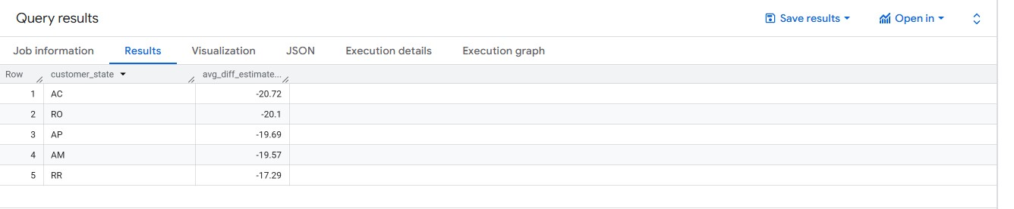
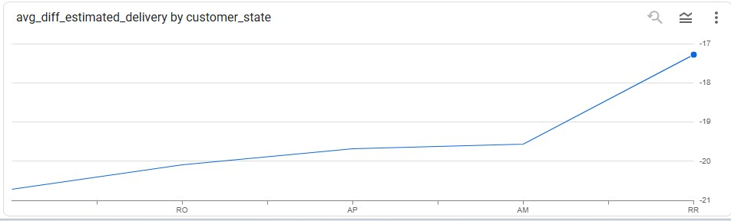
Business Insights:
- High Delivery Accuracy – These states consistently meet or beat the promised delivery dates, showing strong logistics reliability.
- Customer Trust – Accurate delivery times boost customer confidence and reduce complaints or cancellations.
- Operational Efficiency – Likely supported by strategically located warehouses and optimized shipping routes, minimizing delays.
- Benchmark for Improvement – These states can be used as best-practice benchmarks to improve performance in states with large delivery delays.

6.Analysis based on the payments:
6.1.Find the month on month no. of orders placed using different payment types.

Query:

- SELECT
- EXTRACT(YEAR FROM o.order_purchase_timestamp) AS year,
- EXTRACT(MONTH FROM o.order_purchase_timestamp) AS month,
- p.payment_type,
- COUNT(DISTINCT o.order_id) AS no_of_orders
- FROM `customer.orders` o
- JOIN `customer.payments` p
- ON o.order_id = p.order_id
- GROUP BY year, month, p.payment_type 10. ORDER BY year, month, no_of_orders DESC;
11.
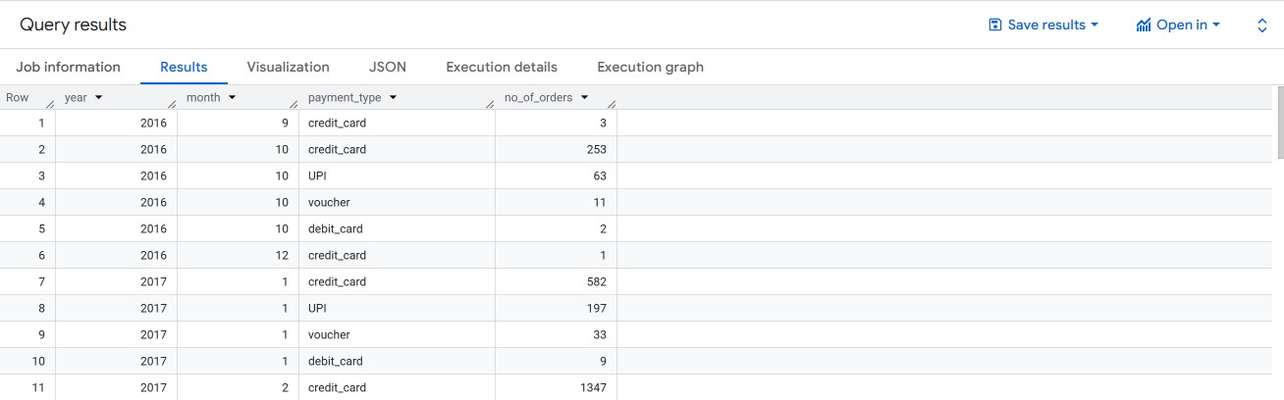
Business Insights :
1.Credit Card dominates → Across most months, credit card is the most widely used payment method, indicating strong customer trust in digital transactions.
2.Boleto (bank slips) popularity → A significant share of customers, especially in earlier months, used Boleto. This reflects cultural preference in Brazil, but adoption declines slightly over time as digital methods grow.
3.COD (Cash on Delivery) is minimal → COD orders are the lowest, showing that customers in Brazil largely prefer prepaid transactions. This reduces cash-handling risks for logistics.
4.Rising trend in Digital Payments → From 2017 to 2018, credit card and online methods steadily increased month-on-month, signalling a shift toward faster, secure, and convenient payments.

6.2.Find the no. of orders placed on the basis of the payment installments that have been paid.
Query: SELECT
p.payment_installments,
COUNT(DISTINCT p.order_id) AS no_of_orders
FROM `customer.payments` p
GROUP BY p.payment_installments
ORDER BY p.payment_installments;

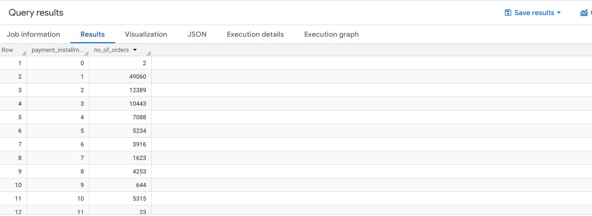
Business Insights :
- Single Installment is Most Common → The majority of customers prefer paying in 1 installment, reflecting trust in online payments and sufficient purchasing power for smaller order values.
- Moderate Adoption of 2–3 Installments → A considerable share of orders are paid in 2–3 installments, suggesting that customers use this option mainly for mid-value purchases.
- Higher Installments (6–12) → A smaller but notable portion of orders are paid in 6+ installments, indicating that customers rely on credit flexibility for high-ticket purchases (e.g., electronics, furniture).
- Customer Affordability Strategy → The availability of installment payments directly impacts conversion rates, as it helps customers with lower upfront affordability but strong intent to purchase.
Actionable Insights & Recommendations ➢ Insights:
- Customer Concentration – A majority of orders come from states like São Paulo and Rio de Janeiro, showing these regions are the company’s strongest markets. Smaller states contribute far less.
- High Freight Costs – Remote states (e.g., North & Northeast) face higher average freight values, making products less attractive compared to urban centers.
- Delivery Delays – The actual delivery time often exceeds the estimated delivery date, impacting customer satisfaction and repeat purchase potential.
- Payment Trends – Credit cards dominate, with many customers preferring installments. Some use boleto (bank slips) but in much lower numbers.
- Seasonality – Order volumes spike during festive months (Nov–Dec), showing strong seasonality in shopping behavior.

➢ Recommendations
- Geo-Targeted Strategy – Focus marketing, discounts, and loyalty programs in high-demand states like São Paulo, while designing special outreach campaigns for smaller markets to expand penetration.
- Supply Chain Optimization – Establish regional warehouses or fulfillment centers in the North/Northeast to cut freight costs and reduce delivery delays, improving competitiveness in those regions.
- Delivery Experience – Partner with local last-mile delivery firms and introduce express delivery options (e.g., same-day or next-day in metros) to enhance customer experience.
- Payment Flexibility – Encourage installment payments for high-ticket items, while offering discounts or cashback for one-time payments to boost cash flow and customer choice.
- Seasonal Planning – Use predictive analytics to forecast demand peaks during festive months, ensuring sufficient stock levels, faster delivery capacity, and targeted promotions.

